Problem Set 10 – Analysis of Covariance

Problem 1 (30 points)
Please access the Leprosy dataset which will be linked on Canvas. This dataset is quite old, but one of the first, best examples of the use of ANCOVA (Snedecor and Cochran 1967, p. 422). Do not do any imputation of missing values and do not remove any missing values unless directed to do so.

Variables are:
- Drug: two antibiotics (A and D) and a control (F)
- PreTreatment: a pretreatment score of leprosy bacilli
- PostTreatment: a posttreatment score of leprosy bacilli

Ten patients were selected for each treatment (Drug), and six sites on each patient are measured for leprosy bacilli. The covariate (a pretreatment score) is included in the model for increased precision in determining the effect of drug treatments on the posttreatment count of bacilli..

Please answer each of the following questions. So that your answers remain focused, you are to include ONLY the item(s) requested (else, your earned credit will be reduced).

- (2 points) Use JMP’s Fit Model to perform a One-Way ANOVA to test for a difference in Drugs (A, D, and F), with PostTreatment as the response. Copy and paste the Effect Test table here.

Source | Nparm | DF | Sum of Squares | F Ratio | Prob > F
Treatment | 2 | 2 | 293.60000 | 3.9831 | 0.0305*

- (3 points) Refer to part a. Adopt an α level of 0.05. In 100 words or less, explain if there was a statistically significant difference among the three treatments (two antibiotics and a conrol).

At a significance level of α = 0.05, there is a statistically significant difference in mean posttreatment leprosy bacilli scores among the three treatments (A, D, and F). The ANOVA results show an F-ratio of 3.9831 and a p-value of 0.0305. Since the p-value is less than 0.05, we reject the null hypothesis that all three treatment means are equal. However, this test does not identify which specific treatments differ significantly.

- (5 points) Fit an ANCOVA model with an interaction term, as described in the lecture video, with Drug as the treatment variable (nominal) and PreTreatment as a covariate (continuos). Refer to the Effects Test table on the ANCOVA output. In 100 words or less, explain how you decide – just using that table – whether the interaction model is necessary or the parallel lines model can be used.

At a significance level of α = 0.05, the interaction between Treatment and PreTreatment is not statistically significant (F = 0.5930, p = 0.5606). Since the p-value is greater than 0.05, we fail to reject the null hypothesis that the slopes are equal across treatments. Therefore, the interaction term is not necessary, and the simpler parallel-lines ANCOVA model can be used to evaluate differences among the three treatments while accounting for pretreatment scores.

- (5 points) Refer to part c. Generate the interaction plot. Copy and paste that plot below and explain in 100 words or less whether the impression from the plot is consistent with the inference in part c.
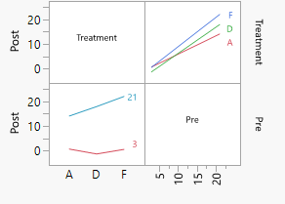

The interaction plot shows that the three treatments (A, D, and F) have relatively similar positive slopes, although some differences are visible. The lines do not appear to diverge substantially, suggesting that the relationship between pretreatment and posttreatment scores is similar across treatments. This is consistent with the ANCOVA interaction test (p = 0.5606), which found no statistically significant interaction. Therefore, the parallel-lines model is appropriate.
- (5 points) Let’s all go back and fit the parallel lines model. Copy and paste the Effects Test table in the space below and explain in 100 words or less if there is a statistically significant difference among the three treatments (two antibiotics and a conrol).

Source | Nparm | DF | Sum of Squares | F Ratio | Prob > F
Treatment | 2 | 2 | 68.55371 | 2.1361 | 0.1384
Pre | 1 | 1 | 577.89740 | 36.0145 | <.0001*

At a significance level of α = 0.05, there is no statistically significant difference among the three treatments after accounting for pretreatment scores (F = 2.1361, p = 0.1384). Since the p-value is greater than 0.05, we fail to reject the null hypothesis that the adjusted treatment means are equal. However, the pretreatment score is statistically significant (p < 0.0001), indicating that pretreatment bacilli levels are significantly associated with posttreatment scores.

- (5 points) Generate the parallel lines plot. Copy and paste that plot in below and in two sentences or less, describe (using only the plot) the relationship about Treatments A and D versus the Control?
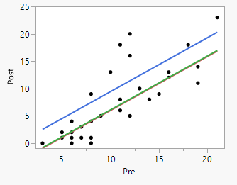

The parallel-lines plot shows that Treatments A and D have lower predicted posttreatment bacilli scores than the control (F) at the same pretreatment score. This suggests that both antibiotics are associated with greater reductions in bacilli compared with the control.

- (5 points) Continue with the parallel lines model. Use JMP to generate the full equations for the three lines fit by the model. Copy and paste that JMP output below.
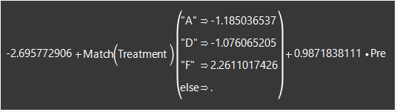

Problem 2 (20 points)
The paper “The Impact of Altitude Training on NCAA Division I Female Swimmers’ Performance” was published in Chance, Volume 37, Issue 2, 2024. The data are in the file FemaleSwimmers.xlsx, and were shared publicly by the authors of the study. Here is the context, borrowed somewhat directly from the abstract of that paper.

Subjects: 69 distance event (1650 freestyle) swimmers.

Variables of Interest:
- HS_1650Free – best high school time
- College_1650Free – best college time
- Altitude – high school training altitude, two levels - above 5000 feet or below 5000 feet
- School – four colleges from which the sample swimmers were taken
- Diff1650 – the difference between College_1650Free and HS_1650Free

Goal of the study: to determine whether athletes who trained in high school at altitudes above 5,000 feet performed better on average in their college events than those who did not train above 5,000 feet. The authors addressed this goal in a rational way by doing a one-way ANOVA with Altitude (as a character variable) as the treatment, and Diff1650 (continuous) as the response.

Please answer each of the following questions. So that your answers remain focused, you are to include ONLY the item(s) requested (else, your earned credit will be reduced).

- (2 points) Repeat the authors work. Use JMP’s Fit Model to perform a One-Way ANOVA to test for a difference in high school altitude training (above 5000 ft, below 5000 ft), with Diff1650 as the response. We are going to call this the Basline Adjustment Approach. Copy and paste the Effects Test table here.

Source | Nparm | DF | Sum of Squares | F Ratio | Prob > F
Altitude | 1 | 1 | 1234.9347 | 0.7990 | 0.3746

- (3 points) Refer to part a. In 100 words or less, address the conclusions suggested by the Effects Test Table from the Baseline Adjustment Approach.

At a significance level of α = 0.05, there is no statistically significant difference in swimming performance improvement between athletes who trained above 5,000 feet and those who trained below 5,000 feet (F = 0.7990, p = 0.3746). Since the p-value is greater than 0.05, we fail to reject the null hypothesis. These results suggest that high school altitude training was not significantly associated with differences in swimming performance improvement from high school to college.

There are other ways to address the study goal, and you will be faced with making these analysis choices in your own work.

- (5 points) The Naïve Approch: an ANOVA with College_1650Free as the response, and Altitude as the treatment. We have included the Effects test table for that run below. In the space following the table, using 100 words or less, address the conclusions suggested by the Effects Test Table and comment on why this approach is less than optimal.

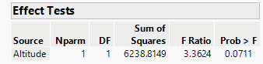

At a significance level of α = 0.05, there is no statistically significant difference in college swimming performance between athletes who trained above and below 5,000 feet (F = 3.3624, p = 0.0711). Since the p-value is greater than 0.05, we fail to reject the null hypothesis. However, the Naïve Approach is less than optimal because it does not account for differences in swimmers' high school performance. These initial differences could influence college swimming times, making it difficult to determine whether altitude training is associated with performance differences.

- (5 points) The ANCOVA Approch: an ANCOVA with College_1650Free as the response, Altitude as the treatment, and HS_1650Free as a covariate. We have included the Effects test table for that run below. In the space following the table, using 100 words or less, address the conclusions suggested by the Effects Test Table and comment on why this approach is better than the Naïve Approach.

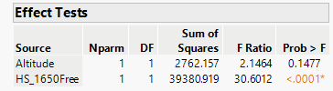

At a significance level of α = 0.05, altitude training was not statistically significant after adjusting for high school swimming performance (F = 2.1464, p = 0.1477). However, high school swimming performance was a statistically significant predictor of college performance (p < 0.0001). The ANCOVA approach is better than the Naïve Approach because it accounts for differences in swimmers' initial performance, allowing a more accurate comparison of college swimming times between altitude groups while reducing unexplained variation.

- (5 points) The ANCOVA Approach and the Baseline Adjustment Approach are very similar in intent. In 100 words or less, compare and contrast the practical conclusions seen in the pair.

Both the ANCOVA and Baseline Adjustment approaches account for differences in swimmers' high school performance, but they do so differently. The Baseline Adjustment Approach analyzes the change in swimming times from high school to college, while ANCOVA adjusts college swimming times using high school performance as a covariate. Neither approach found a statistically significant difference between altitude training groups (Baseline Adjustment p = 0.3746; ANCOVA p = 0.1477). Therefore, both approaches lead to the same practical conclusion: there is insufficient evidence that high school altitude training is associated with improved college swimming performance.

